EX NO:1(A)  **WEIGHT OF NUMBER OF STEEL BARS.**

DATE:29.11.22.

**AIM:**TO write an algorithm and draw a flow chart for the given problem.

**ALGORITHM:**

STEP 1: Start.

STEP 2: Get no of rods and Diameter of its ends.

STEP 3: Set counter i =1.

STEP 4: If i <= n, Otherwise Goto Step 6.

4.1: UnitWt =D^2/162

4.2: Wt = n*D*UnitWt.

4.3: Total = Total+Wt.

4.4: i = i+1.

STEP 5: Display Total.

STEP 6: Stop.

**FLOWCHART:**

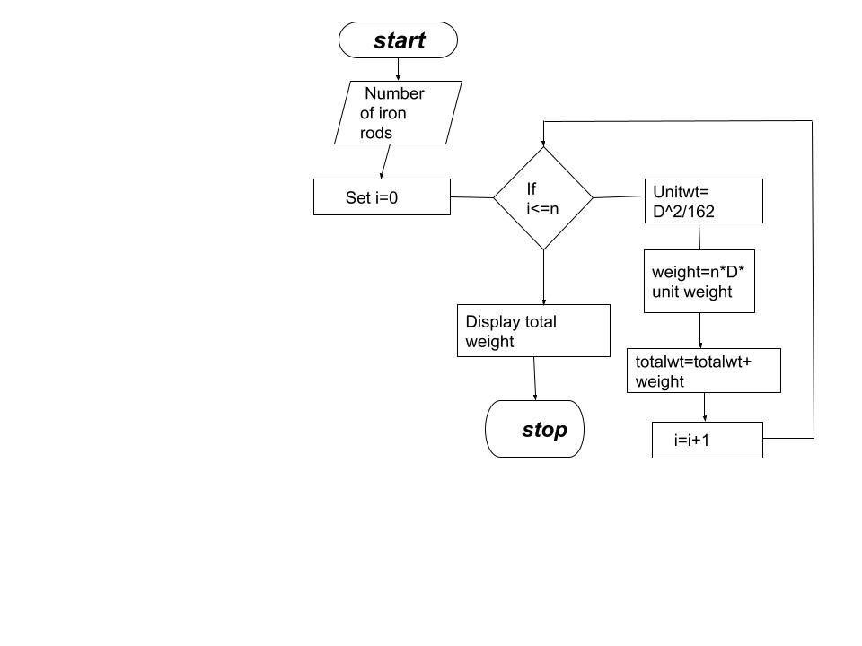

**PSEUDOCODE:**

BEGIN

READ n, d

INITIALIZE i =0

IF i <= n

THEN UnitWt = d^2/162

Wt = n*d*UnitWt

Total = Total +Wt

i = i+1

DISPLAY TW

END

**RESULT:** Thus the algorithm and flowchart has been written for the given problem.

NAME:SWETHHA M

ROLL NO:22CSEB32

EX NO:1(B)  **WEIGHT OF A MOTOR BIKE.**

DATE:29.11.22.

***AIM:*** TO write an algorithm and draw a flow chart for the given problem.

***ALGORITHM:***

STEP 1: Start.

STEP 2: Read the dry weight(without liquids),wet weight(with liquids),rider’s weight.

STEP 3: Calculate GVWR, its given by dry weight+wet weight.

STEP 4: Now, calculate Gross weight by subtracting wet weight from GVWR.

STEP 5: Display Gross weight.

STEP 6: Stop.

**FLOWCHART:**

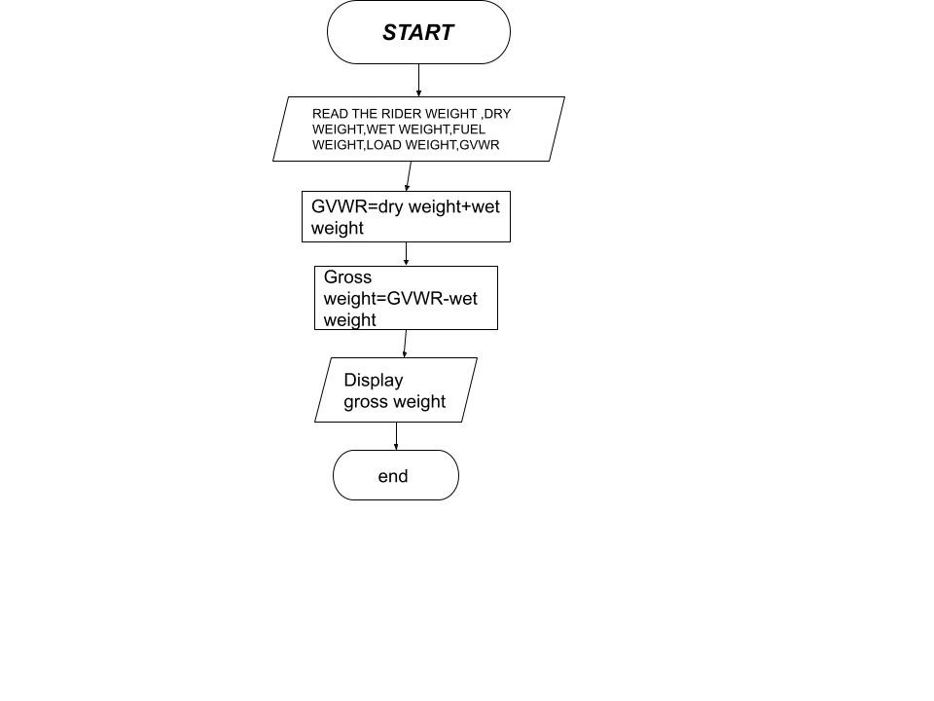

**PSEUDOCODE:**

BEGIN

READ the rider’s weight,dry weight,wet weight

CALCULATE GVWR by the formula GVWR=wet weight+dry weight

Gross weight=GVWR-wet weight.

DISPLAY Gross weight.

END.

***RESULT:*** Thus the algorithm and flowchart has been written for the given problem.

NAME:SWETHHA M

ROLL NO:22CSEB32

EX NO:1(B) **GRADE CALCULATION.**

DATE:29.11.22.

**AIM:**TO write an algorithm and draw a flow chart for the given problem.

**ALGORITHM:**

STEP 1: Start .

STEP 2: Get the no.of students.

STEP 3: Initialize i=0.

STEP 4: If i<n,get the name ,roll number,m1,m2,m3 and goto 5,else stop.

STEP 5: Calculate total=m1+m2+m3,avg=total/3 and display name ,roll no,total.

STEP 6 : If A>=90,print grade “A” and goto 7,else goto 6.1.

STEP 6.1: If A>=80,print grade “B” and goto 7,else goto 6.2.

STEP 6.2: If A>=50,print grade “C” and goto 7,else goto 6.3.

STEP 6.3: If A>=40,print grade “D” and goto 7,else display FAIL.

STEP 7: i=i+1 and goto step 4.

STEP 8: End.

**FLOWCHART:**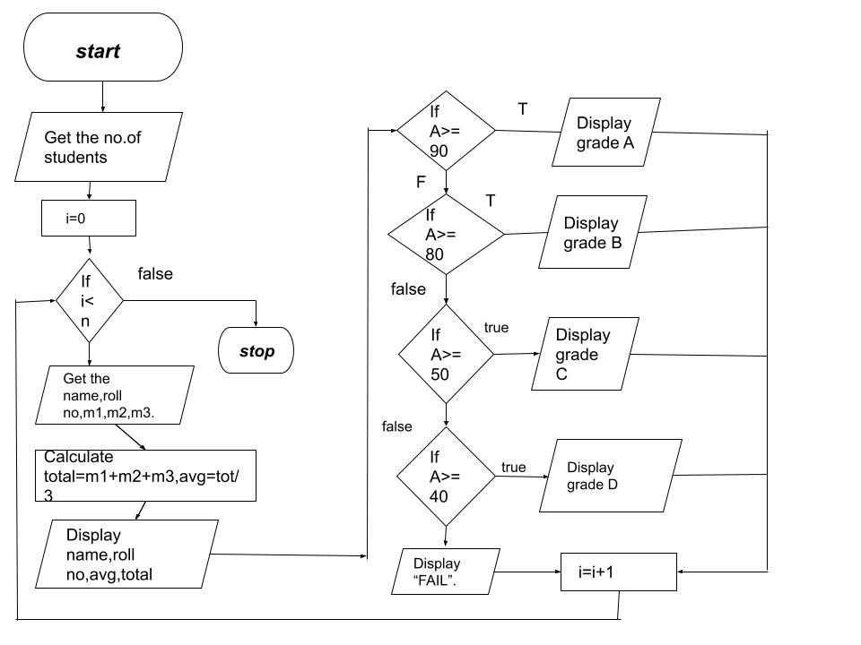

**PSEUDOCODE:**

BEGIN

READ n

INITIALIZE i=0

IF i<=n

THEN READ name,roll no, m1,m2,m3

CALCULATE Total=m1+m2+m3,AVG=total/3

DISPLAY name,roll no, Total,AVG.

IF m>=90

DISPLAY Grade A

IF m>=80

DISPLAY Grade B

IF m>=50

DISPLAY Grade C

IF m>=40

DISPLAY Grade D

ELSE

DISPLAY Fail

INCREMENT i by 1 and GOTO IF condition.

END

**RESULT:** Thus the algorithm and flowchart has been written for the given problem.

NAME:SWETHHA M

ROLL NO:22CSEB32

EX NO:1(D) **ELECTRICITY BILLING.**

DATE:29.11.22.

**AIM:**TO write an algorithm and draw a flow chart for the given problem.

**ALGORITHM:**

STEP 1: Start.

STEP 2: Read no.of.units consumed as “N”.

STEP 3: Check if n<=100,if true, display no current charge else goto 4.

STEP 4: Check if n<=500,if true,for 100 units no charge,for units 101+200,E.C=100*2=200,for remaining ,calculate E.C 2 for remaining units =(n-200)*3.

STEP 5: Check if n>500,if true,for 100 units no charge,for 101-200 units,E.C=100*3.5=350,for 201-500 units ,E.C=300*4.6=1260.

STEP 6: Total bill =E.C+D.C+F.C.

STEP 7: Stop.

**FLOW CHART:**

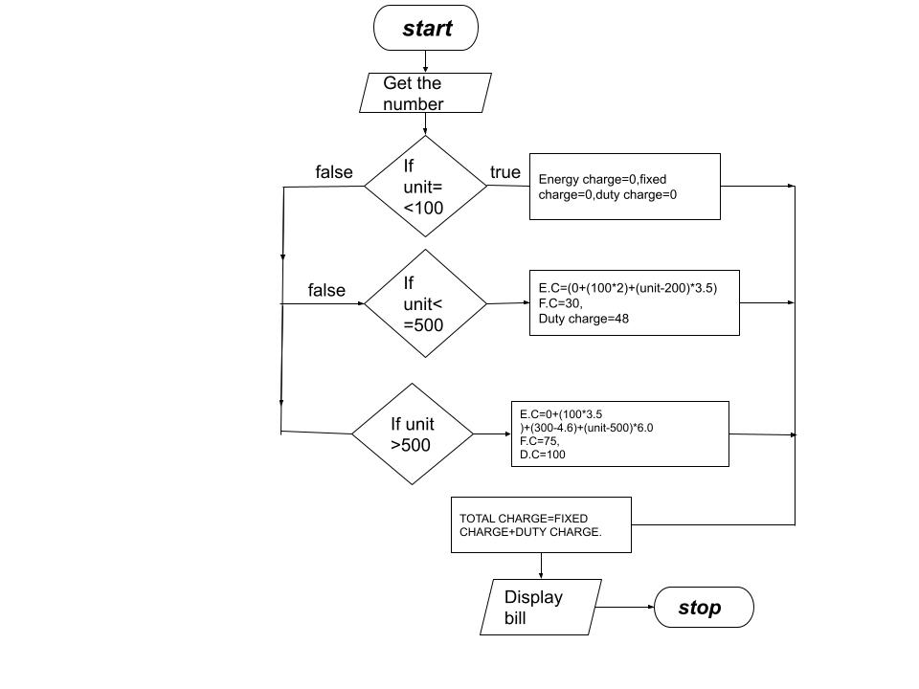

**PSEUDOCODE:**

BEGIN

READ N

SUBTRACT Unit = current – N

IF Unit<=100

EC = 0, FC =0, DC =0

IF Unit<=500

EC = 0+(100*2)+(Unit-200)*3.5, FC = 30, DC = 48

IF Unit > 500

EC =0+(100*3.5)+(300*4.5)+(Unit-500)*6, FC = 75,

DC=100

ADD TC = EC+FC+DC

DISPLAY BILL

END

**RESULT:** Thus the algorithm and flowchart has been written for the given problem.

NAME:SWETHHA M

ROLL NO:22CSEB32

EX NO:1(E)  **RETAIL SHOP BILLING**

DATE:29.11.22.

**AIM:** TO write an algorithm and draw a flow chart for the given problem.

***ALGORITHM:***

STEP 1: Start.

STEP 2: Get the no.of .items purchased.

STEP 3: Set i=0,total=0.

STEP 4: If i<=n,get item-name,price,discount else goto step 8.

STEP 5: Sub total=count*price-D/100.

STEP 6: Total=total +subtotal.

STEP 7: i=i+1.

STEP 8: Stop.

**FLOWCHART:**

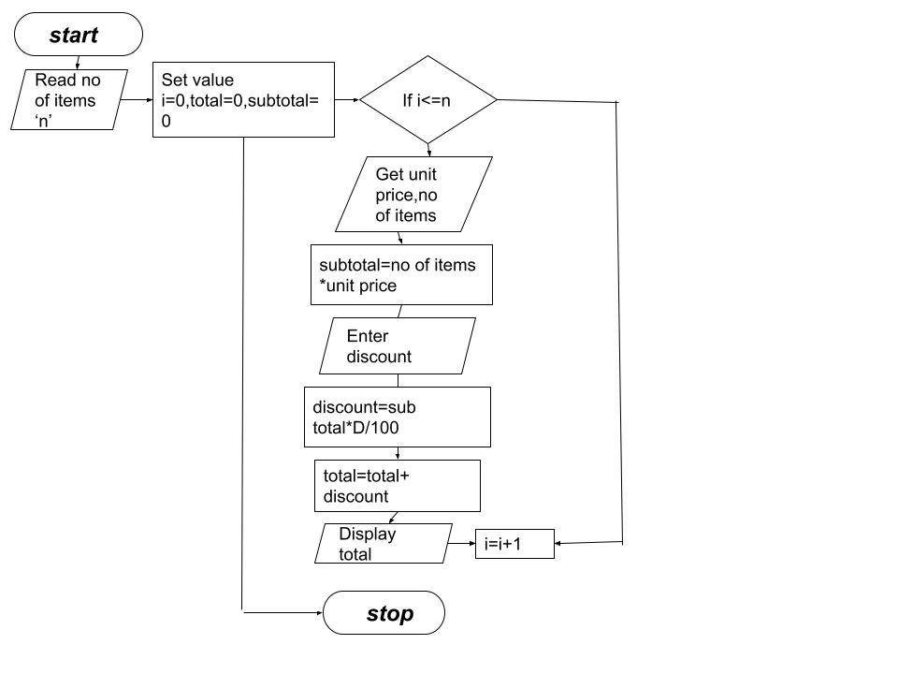

**PSEUDOCODE :**

BEGIN

READ n

INITIALIZE i= 0, Total= 0, STotal =0

IF i<=n

READ unit price,nop of items.

THEN STotal = no*Up

Dis = STotal*Discount/100

Total = Total +Dis

i= i+1

DISPLAY Total

END

**RESULT:** Thus the algorithm and flowchart has been written for the given problem.

NAME:SWETHHA M

ROLL NO:22CSEB32

EX NO:1(F) **SINE FUNCTION.**

DATE:29.11.22.

**AIM:** TO write an algorithm and draw a flow chart for the given problem.

**ALGORITHM:**

STEP 1: Start.

STEP 2: Get value of “X” and “N”.

STEP 3: Set i=0,sine=0 and import math.

STEP 4: If i<n, y=X*3.14/180, else goto step 7.

STEP 5: Sine=sine+(y**2*i+1)/(math.factorial(2*i+1)*(-1**i)).

STEP 6: i=i+1.

STEP 7: Display sine.

STEP 8: Stop.

**FLOWCHART:**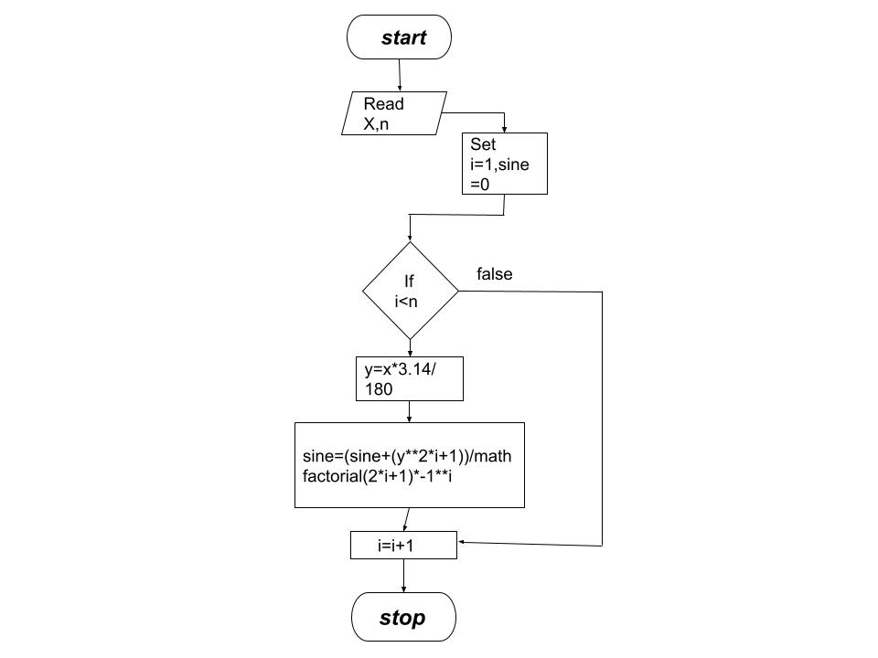

**PSEUDOCODE:**

BEGIN

READ x, n

INITIALIZE i=1, sine =0

IF i < n

THEN y = x*3.14/180

sine = (sine+(y^2*i+1)/(math.factorial(2*i+1)))*-1^i

i=i+1

DISPLAY sine

END

**RESULT:** Thus the algorithm and flowchart has been written for the given problem.

NAME:SWETHHA M

ROLL NO:22CSEB32

EX NO:1(F) **ELECTRIC CURRENT IN 3 PHASE AC CIRCUIT**

DATE:29.11.22.

**AIM:**TO write an algorithm and draw a flow chart for the given problem.

**ALGORITHM:**

STEP 1: Start.

STEP 2: Get the value oFP.F,current ,voltage.

STEP 3: Calculate P using P=1.732*P.F*I*V.

STEP 4: Display P .

STEP 5: Stop.

**FLOWCHART:**

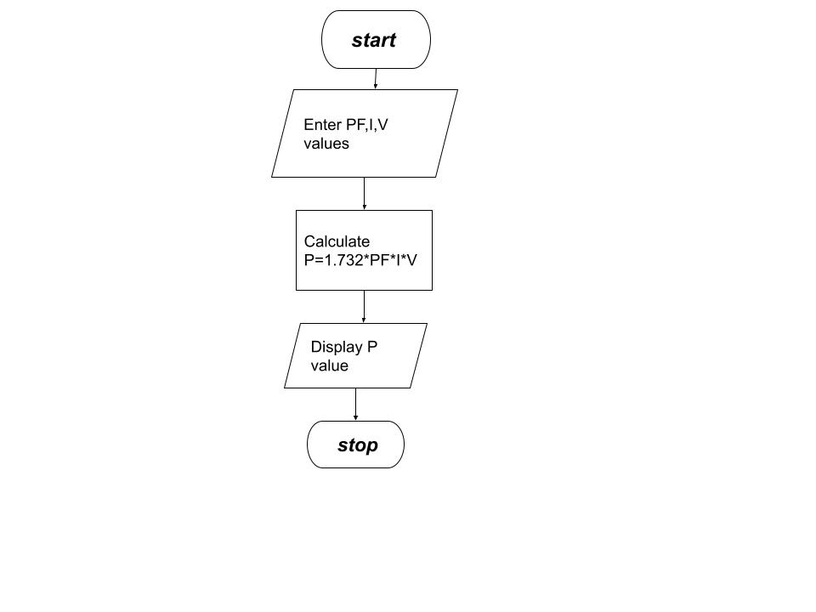

**PSEUDOCODE:**

BEGIN

READ Pf, I, V

CALCULATE P = (3)^(1/2)*Pf*I*V

DISPLAY P

END

**RESULT:** Thus the algorithm and flowchart has been written for the given problem.

NAME:SWETHHA M

ROLL NO:22CSEB32